**LAB 3**

• Write scripts /commands / syntax to print a message “Welcome to the World of Shell Scripting” 10 times.

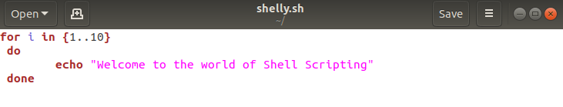

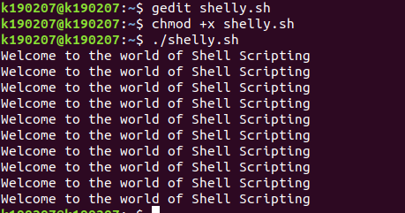

• Write scripts /commands / syntax to take input and print your name, degree program information, batch No and course title.

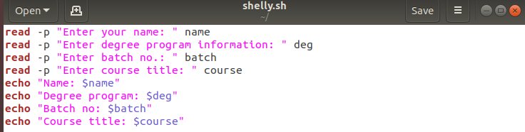

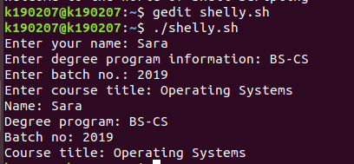

• Write scripts /commands / syntax that take input and check the number is positive or negative.

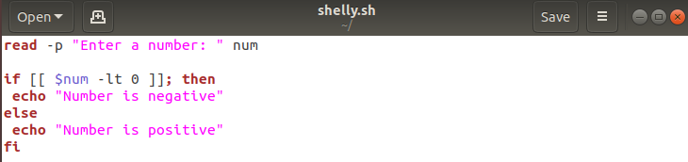

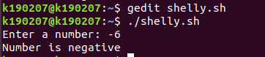

• Write scripts /commands / syntax that take input and check the number is prime or not.

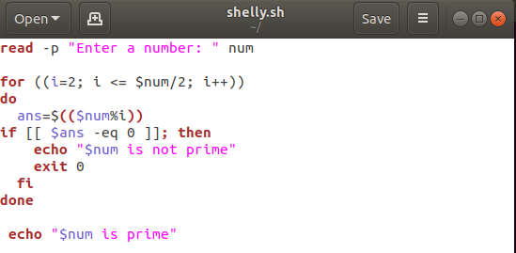

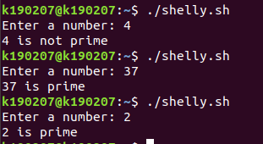

• Write scripts /commands / syntax that take input and check the maximum and minimum of 5 input numbers.

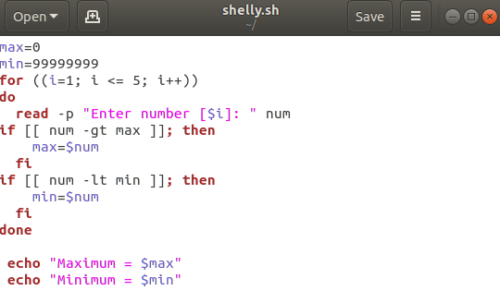

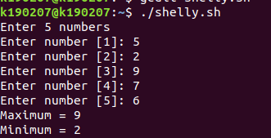

• Write scripts /commands / syntax to generate the Fibonacci series.

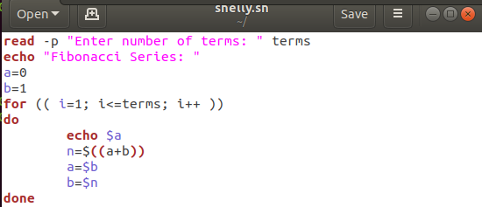

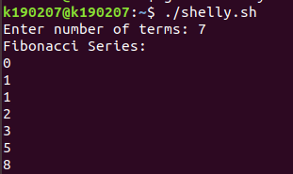

• Write scripts /commands / syntax to find out the factorial of given input number.

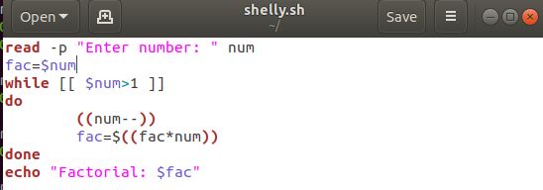

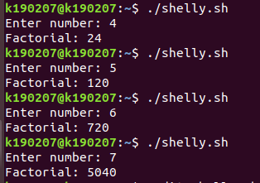

• Write scripts /commands / syntax for moving files into three subdirectories directories: shelldir, cdir, jpgdir according to their extensions.





• Write a single script of all necessary software installation in your system.

(Important)

